File system files making guide
- Introduction
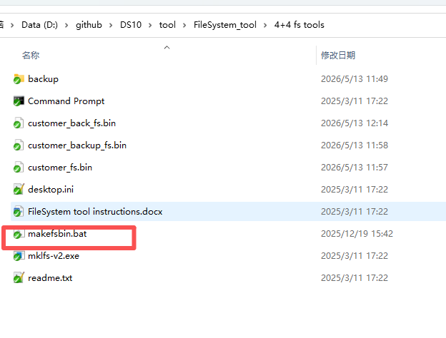
- backup-The folder contains the directory of system/audio files, and store import files and export files from customer_fs.bin under this folder
For example, if you want to pre create some configuration files and certificates into the file system You can create folders in the backup and place these files in a new folder
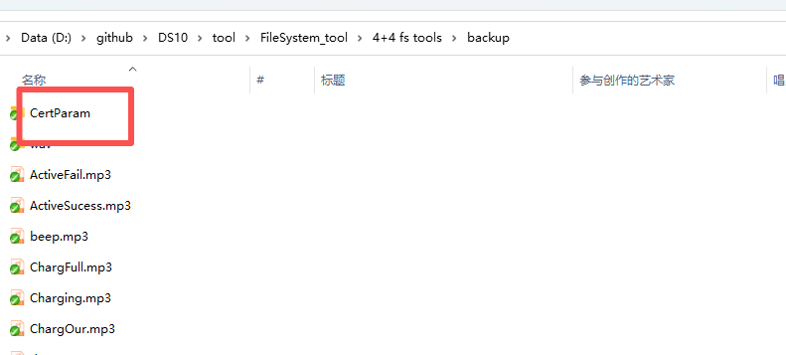
- customer_fs.bin is input/output FS file that used by this tool（customer_backup_fs.bin – external flash file system，if making external file system, need manually rename）
- makefsbin.bat – batch file
- FS file generate
- Place the system/audio files to be imported in the backup folder
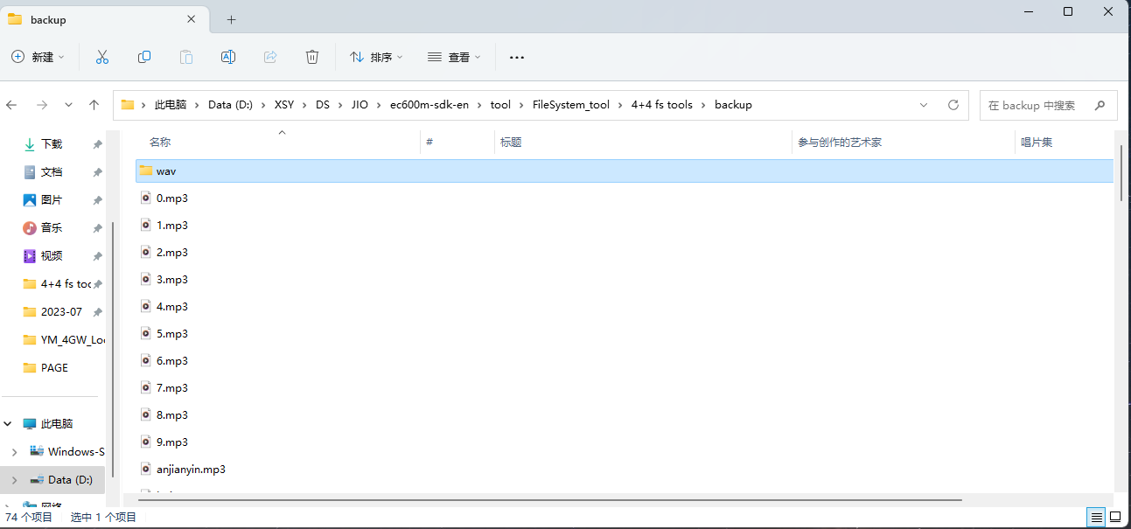
- run makefsbin.bat
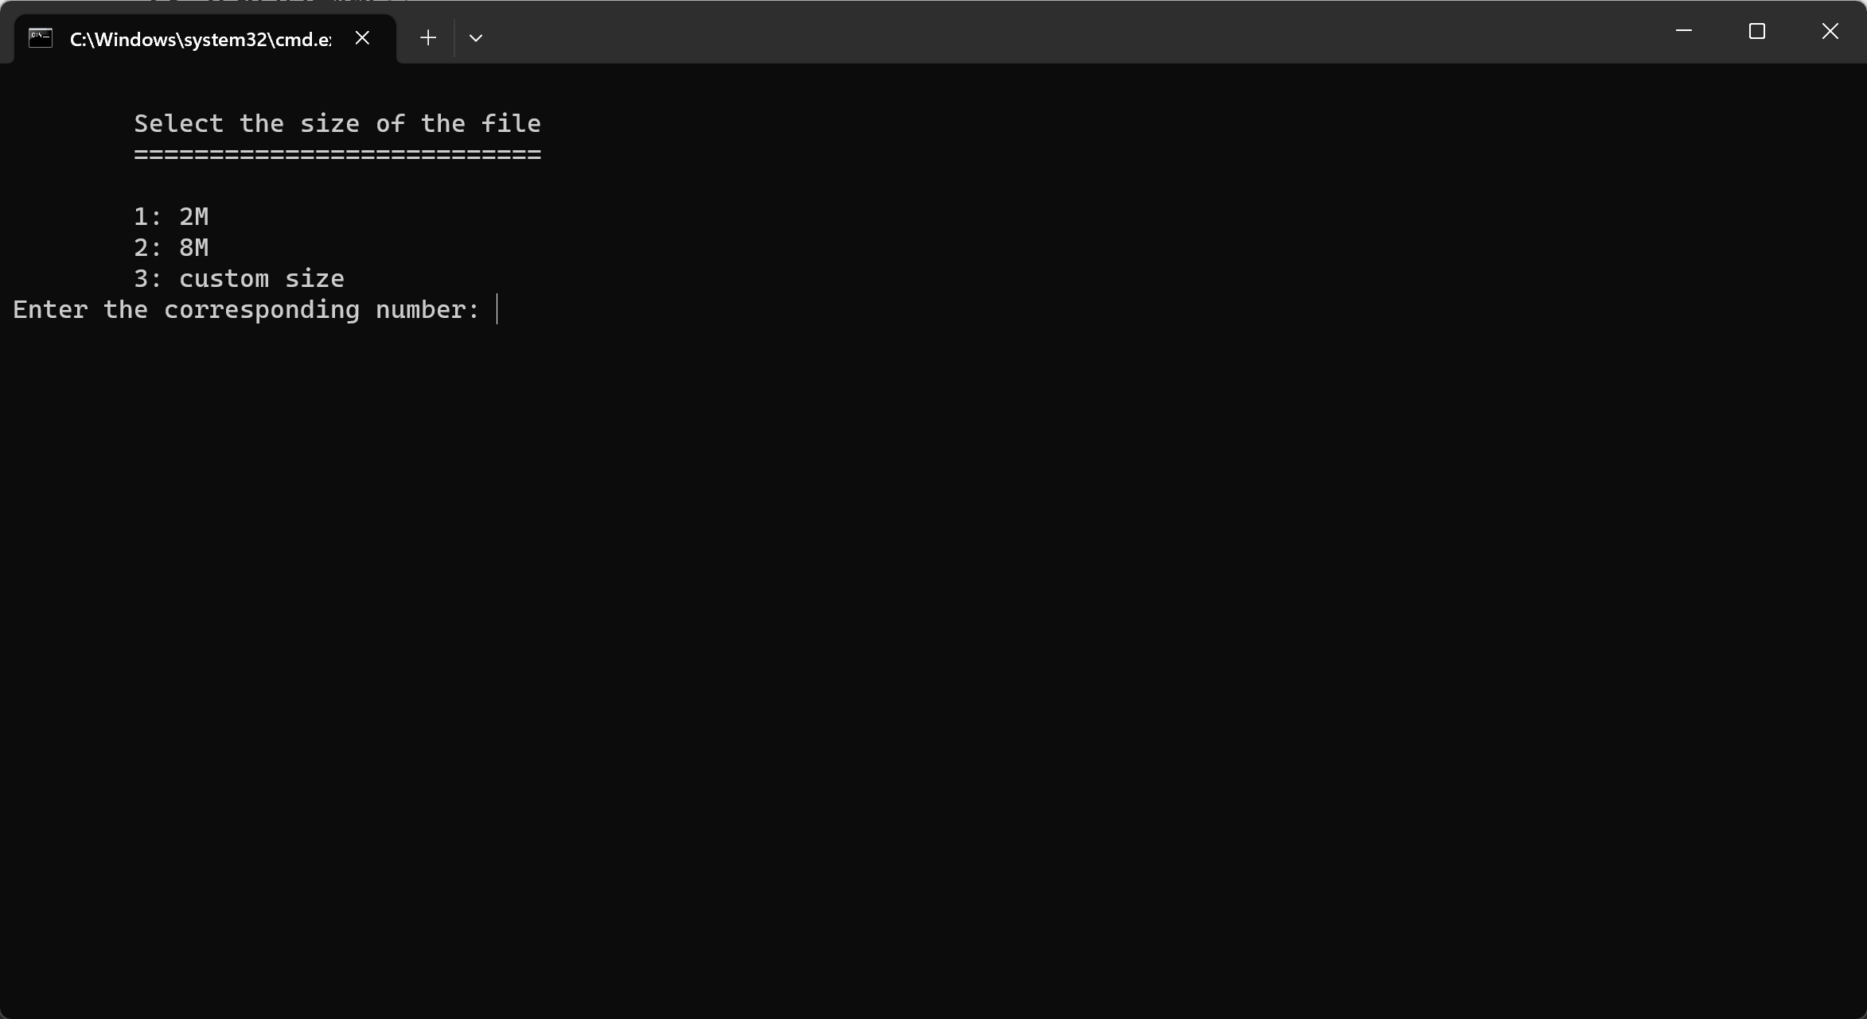
- Select the internal or external flash file system that you want to make (option 3 not support)

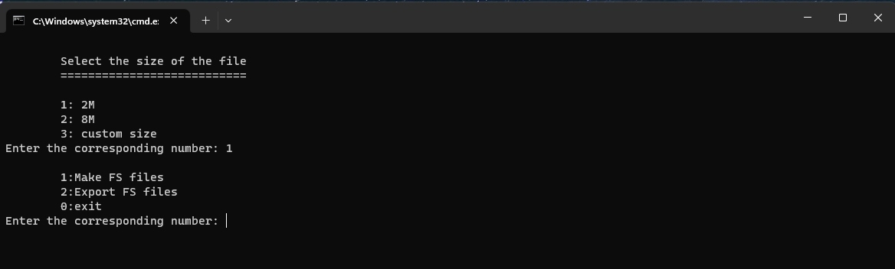
- After that, we choose the 1st option, make the FS file, and generate the customer _fs.bin is the FS file that is produced
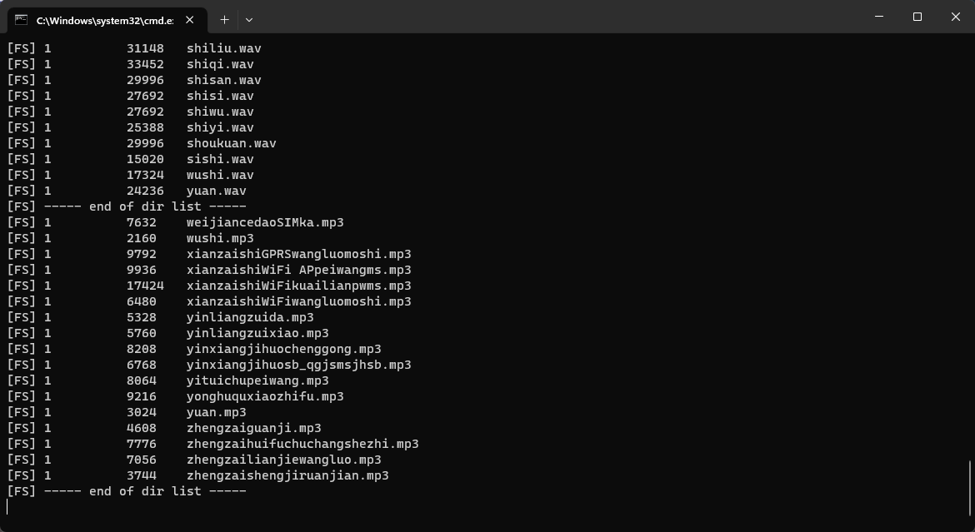
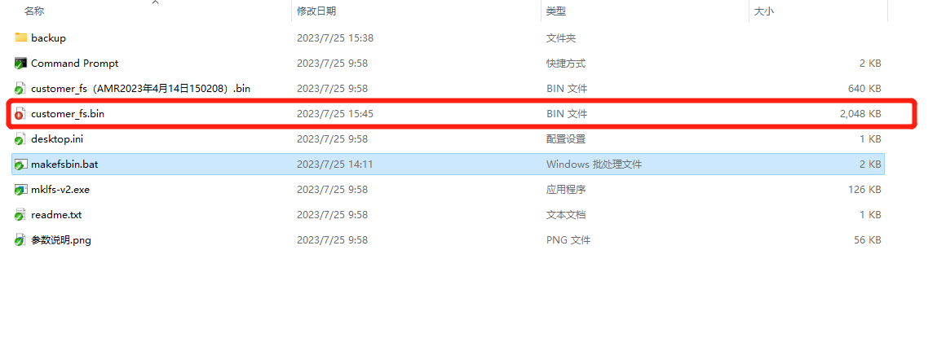

If select Option 1, A 2MB customer_fs. bin file will be generated. This file can be used on both DS10-S-CN and DS10-S-EU devices. Neither of these devices has a display screen
We need to place the generated customer _fs. bin file in the following directory
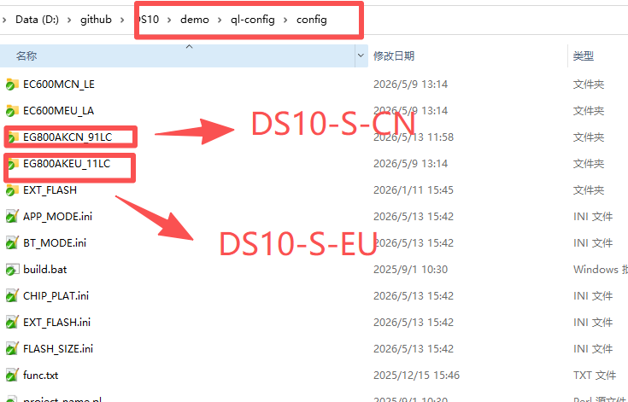

If select Option 2, A 8MB customer_fs. bin file will be generated. This file can be used on both DS10-D-CN and DS10-D-EU devices. These two devices have display screens
We need to place the generated customer _fs. bin file in the following directory
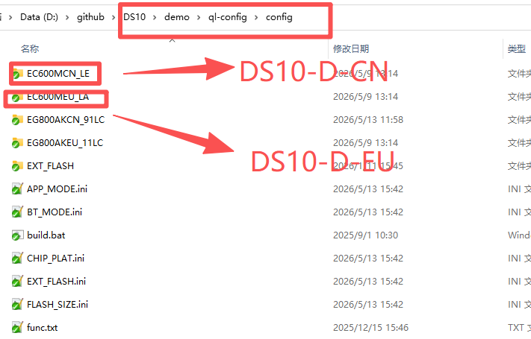

- Export files from the file system
- Change the file name of the FS file to be exported to customer_fs.bin
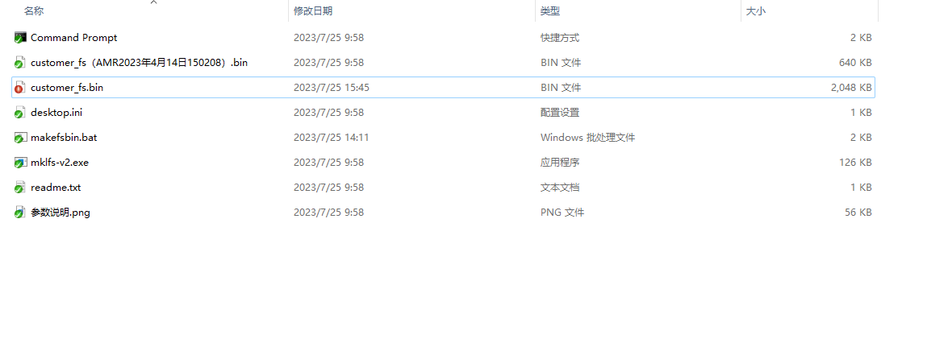
- Run the script and select or enter “customer_fs.bin” file size（we choose 1 on demo）
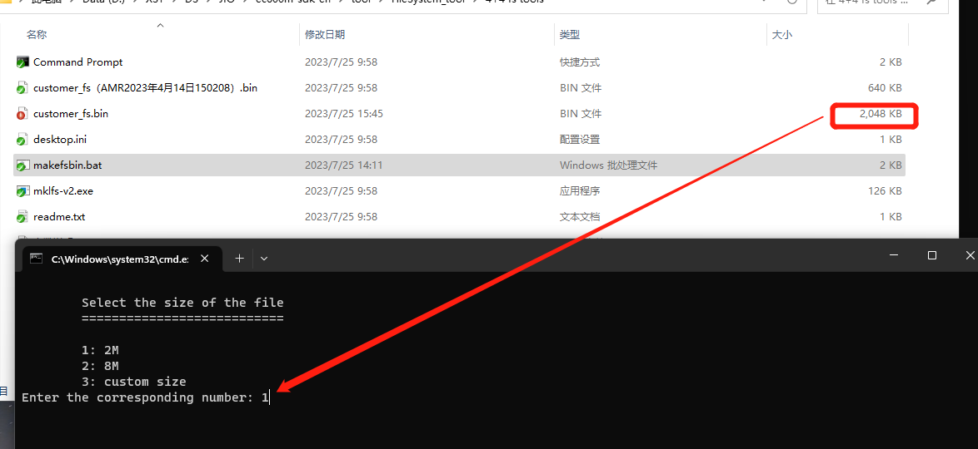
- After confirmation, select option 2 to export the file
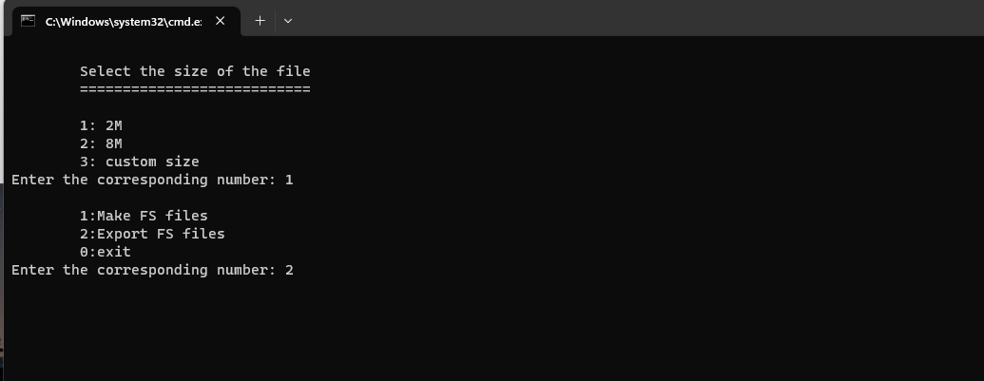
- The exported file is stored in the backup folder
